Name(s) of Traveler(s): Samson Mwinga[1], Nasser Mbaziira1, Phulu Bayobuya1, Stanley Stephanus[2]

Place(s) Visited: Kavango East and Zambezi Regions, Namibia

Dates Visited: September 01 - 05, 2014

1. **Background**

The USAID-funded Systems for Improved Access to Pharmaceuticals and Services (SIAPS) Program supports the Electronic Dispensing Tool (EDT) and promotes the use of EDT data by regional pharmacists for programmatic management at the regional and health facility levels.

The effective implementation and use of EDT enables access by regional pharmacists to region-specific profiles on the existing national EDT database (NDB) to facilitate their participation in the monitoring of antiretroviral therapy (ART) data quality and ART-related activities in their regions and the local use of ART data.

Regional pharmacists and other ART health workers have been trained on the EDT and EDT Mobile *(for ongoing regional support)*. Health facilities have been provided with limited 3G connectivity for electronic data migration to national level and for provision of IT support remotely.

The ART program requires access to reliable patient and ARV medicines data at all times, and optimal availability of EDT and the EDT Mobile at all health facilities countrywide is essential, so that complete data can be availed in a timely manner for analysis and decision making. Zambezi and Kavango East regions are facing challenges to use the EDT Mobile devices to collect ART data, and pharmacy and nursing staff need onsite support to be able to use the EDT Mobile. Currently data on ARVs dispensed at primary healthcare (PHC) facilities is manually entered into the EDT system at the main sites creating room for errors and data gaps.

The effective use of EDT Mobile devices will contribute towards availability and usage of strategic information on pharmaceutical systems for decision making by the ART program.

1. **Purpose of Trip, Scope of Work and Key Objectives**

This trip was aimed at supporting the Ministry of Health and Social Services (MoHSS) to strengthen the efficiency and integration of the EDT Mobile used at PHC facilities with the EDT at main sites, to ensure data completeness, and improve data accuracy and reliability. The activity involves updating the EDT Mobile devices in use at PHC facilities in the Kavango East and Zambezi regions, to ensure optimal collection of data on ARV dispensing.

The following activities were planned for this trip:

1. Discuss challenges faced with the EDT Mobile implementation with regional pharmacist and ART Pharmacy staff at main site and review the ART services process flow of the EDT Mobile
2. Service EDT computer equipment and update computer software.
3. Guide pharmacy staff to be able to troubleshoot, reload software, test and update the EDT Mobile
4. Discuss challenges faced with the EDT Mobile implementation with nursing staff at ART PHC facilities and review the ART services process flow of the EDT Mobile
5. Provide onsite hands-on guidance, including troubleshooting of faulty devices and monitor use of the EDT Mobile by nursing staff
6. Provide practical guidance to pharmacy staff to upload data onto the EDT system at main site
7. **Activities, Principal findings and Accomplishments**

Prior to the trip, a meeting was held at the MoHSS/Directorate of Special Programs (DSP) to discuss the technical support required from SIAPS and to develop an action plan for the challenges that were faced by PHC facilities in Kavango and Zambezi regions where the EDT Mobile devices were installed. To that effect, the MoHSS/DSP drafted and disseminated a formal notification of the intended technical support visit to facilities in the Kavango and Zambezi regions (Annex 3).

**Onsite Training Approach Used**

Healthcare workers at sites visited were oriented, provided with hand-on guidance, and monitored in the use of the EDT Mobile. The table below provides the list of five EDT Mobile related processes, which were used to guide the hands-on training proceedings onsite.

|  |  |
| --- | --- |
| EDT Mobile Process | Facility Type |
| 1. Maintenance of the device (troubleshooting and setting up the date and time) | Main/PHC site |
| 1. Creating, exporting data from the EDT PC and loading onto the EDT Mobile | Main site |
| 1. Dispensing using the EDT Mobile (including use of 3-digit medicine codes to improve efficiency) | Main/PHC site |
| 1. Sending dispensing data from the EDT Mobile to the EDT PC | Main site |
| 1. Importing and verifying data on the main site’s EDT system | Main site |

Table 1: EDT Mobile Processes Used to Guide Onsite Training Proceedings

**Day 1 (September 01, 2014)**

On the first day the team discussed the activities to be implemented in detail and formulated strategies on how to effectively carry out tasks identified. All the mobile devices carried from Windhoek were updated with current software version and tested. During this exercise the team encountered a challenge, where data on the EDT Mobile was not over-written after being uploaded onto the EDT computer. The data collection terminal (EDT Mobile) programmer was contacted to provide a solution to the challenge and he responded with a new version of the software the next day.

The team provided technical assistance to the Rundu Intermediate Hospital ART Pharmacy, where the EDT was installed on a second computer system to improve the efficiency of the dispensing activities at the facility. EDT Mobile devices received from the PHC facilities were also reloaded and tested with current software version.

**Days 2 (September 02, 2014)**

All the EDT Mobile devices (those from Windhoek and Rundu district) were reloaded with new software received from the programmer. The devices from Rundu district were additionally updated with current data files from the EDT at Rundu ART Pharmacy. The Pharmacy Assistants (PAs); Mr. Brendan Lyonga and Mr. Andrease Soke were guided through the five EDT Mobile related processes (Table 1, above).

On the same day the team travelled to Zambezi region, and paid a courtesy visit to Katima Mulilo Hospital Main Pharmacy and ART Clinic Pharmacy. The mobile devices from 12 PHC facilities were collected by the team, updated with the new EDT Mobile software and tested.

**Day 3 (September 03, 2014)**

The team met with the ART Pharmacy staff; Mr. Wilten Chikombo and Mr. George Lukonga, who were guided through the five EDT Mobile related processes (Table 1, above). EDT data files were uploaded on all mobile EDT devices, which had been returned to the hospital.

The team visited five PHC facilities including two health centers (Sangwali and Sibbinda) and three clinics (Chinchimane, Choi and Sesheke); and each site was provided with a functional EDT Mobile. Nine healthcare workers (including two from the main site) were trained on how to maintain the device and use it to collect dispensing data (Annex 1). Three-page leaflets with medicine barcodes and numerical codes were distributed for use during dispensing. Challenges previously encountered were discussed and addressed.

**Day 4 (September 04, 2014)**

On day four the team visited seven PHC facilities including Bukalo Health Centre and six clinics (Ngoma, Katima Mulilo, Ngwezi, Schuckmansburg, Mavuluma and Kasheke); and provided each site with a functional EDT Mobile. 12 healthcare workers were trained on how to maintain the device and use it to collect dispensing data (Annex 1). Three-page leaflets with medicine barcodes and numerical codes were distributed for use during dispensing. Challenges previously encountered were discussed and addressed.

**Day 5 (September 05, 2014)**

On day five the team held a meeting with the ART Pharmacy staff at Katima Mulilo Hospital and provided feedback from the PHC facilities visited during the two day supportive visits.

The team travelled back to Rundu and followed up on the use of the EDT Mobile at Rundu ART Pharmacy in the last three days after the initial visit. Data was up loaded on to the PC and the users reported no challenges on the system.

1. **Follow-up Actions Needed**

|  |  |  |  |  |  |
| --- | --- | --- | --- | --- | --- |
| **#** | **Activity description** | **Location** | **Person responsible** | **Timeline** | **Method of verification of completion** |
|  | Courtesy calls to the PHC facilities to follow up on progress made using the EDT Mobile. | Windhoek | Sam/Stanley | Weekly  Sep 8 – 22, 2014 | # of IMAI sites followed up. |
|  | Send EDT Mobile devices towards month end, and minimize the number of appointments for ARV pickups during that period. | Zambezi | IMAI site I/Charges | Monthly | Data uploaded every month. |
|  | Follow up supervisory visits to Zambezi and Kavango East regions on implementation and use of mobile EDT devices. | Zambezi & Kavango East | Sam, Phulu, Greatjoy & Stanley | Oct 6 – 10, 2014 | Supervisory visits conducted. |
|  | Provide feedback and share copy of trip report with MoHSS/DSP | Windhoek | Phulu/Sam | 12 Sep 2014 | Email and meeting with MoHSS/DSP |

1. **Annexes**

**Annex 1: Key Persons Met (List of Personnel Trained)**

| **Name** | **Title** | **Organization/Affiliation** |
| --- | --- | --- |
| 1. Mr. Brendan Lyonga | Pharmacy Assistant | Rundu Hospital |
| 1. Mr. Andrease Soke | Pharmacy Assistant | Rundu Hospital |
| 1. Mr. Mutumba Syben | Enrolled Nurse | Chinchimane Clinic |
| 1. Ms. Annette Sitina | Registered Nurse | Sangwali Health Centre |
| 1. Ms. Ntombrudwa N. | Registered Nurse | Ngoma Clinic |
| 1. Mr. Muriro Chris | Registered Nurse/Midwife | Bukalo Health Centre |
| 1. Mr. Santeombo J.S | Registered Nurse | Katima Clinic |
| 1. Mr. Muruthi A. | Registered Nurse | Katima Clinic |
| 1. Ms. Mubumbutwa Caroline | Enrolled Nurse/Midwife | Katima Clinic |
| 1. Mr. Sasamu Sinte | Enrolled Nurse/Midwife | Katima Clinic |
| 1. Ms. Ndambo Funny | Registered Nurse | Ngwezi Clinic |
| 1. Ms. Mwiya Faustina | Enrolled Nurse/Midwife | Ngwezi Clinic |
| 1. Ms. Susan Sihishebo | Enrolled Nurse/Midwife | Ngwezi Clinic |
| 1. Mr. Kwenani Sililo | Enrolled Nurse | Schuckmansburg Clinic |
| 1. Mr. Mufwambi Bensen | Enrolled Nurse/Midwife | Mavuluma Clinic |
| 1. Ms. Nakwezi R. Sililo | Enrolled Nurse/Midwife | Kasheshe Clinic |
| 1. Mr. Wilten Chikombo | Pharmacist/Technologist | Katima Mulilo Hospital |
| 1. Mr. George Lukonga | Senior Pharmacist Assistant | Katima Mulilo Hospital |
| 1. Ms. Judith Ndozi | Registered Nurse | Choi Clinic |
| 1. Ms. Cordilia Munalula | Enrolled Nurse | Choi Clinic |
| 1. Ms. Priscah Sikubo | Enrolled Nurse | Sesheke Clinic |
| 1. Ms. Lydia Mukungo | Community Counsellor | Sesheke Clinic |
| 1. Ms. Sabrina Muzibe | Enrolled Nurse | Sibbinda Health Centre |

Table 2: List of personnel trained per facility visited

**Annex 2: Summary of Active Patients by PHC site**

|  |  |  |  |
| --- | --- | --- | --- |
| PHC Facility Name | No. of Active  Patients | EDT Main Site | Region |
| 1. Ngewzi Clinic | 527 | Katima Mulilo State Hospital | Zambezi |
| 1. Mavuluma Clinic | 525 |
| 1. Bukalo Health Centre | 426 |
| 1. Sibbinda Health Centre | 300 |
| 1. Sesheke Clinic | 268 |
| 1. Katima Clinic | 262 |
| 1. Sangwali Health Centre | 216 |
| 1. Ngoma Clinic | 207 |
| 1. Choi Clinic | 195 |
| 1. Chinchimane Clinic | 170 |
| 1. Kasheshe Clinic | 90 |
| 1. Schuckmansburg Clinic | 48 |
| 1. Impalila Clinic | 131 |
| 1. Sachona Clinic | 66 |
| 1. Chetto Clinic | 40 |
| Total Active for PHC sites: | **3,471** |  | |
| Total Active for Main Site: | **4,569** |
| Total Active Zambezi Region: | **8,040** |

Table 3: No. of Active Patients at PHC facilities as at 1 September 2014 (Zambezi region)

|  |  |  |  |
| --- | --- | --- | --- |
| PHC Facility Name | No. of Active  Patients | EDT Main Site | Region |
| 1. Ndama Clinic | 383 | Rundu Intermediate Hospital | Kavango East |
| 1. Shambyu Health Centre | 365 |
| 1. Bunya Health Centre | 298 |
| 1. Mupini Health Centre | 181 |
| 1. Nkarapamwe Clinic | 169 |
| 1. Sauyemwa Clinic | 54 |
| Total Active for PHC sites: | **1,450** |  | |
| Total Active for Main Site: | **5,734** |
| Total Active Rundu District: | **7,184** |

Table 4: No. of Active Patients at PHC facilities as at 1 September 2014 (Rundu district)

**Annex 3: Letter to Kavango and Zambezi regions**

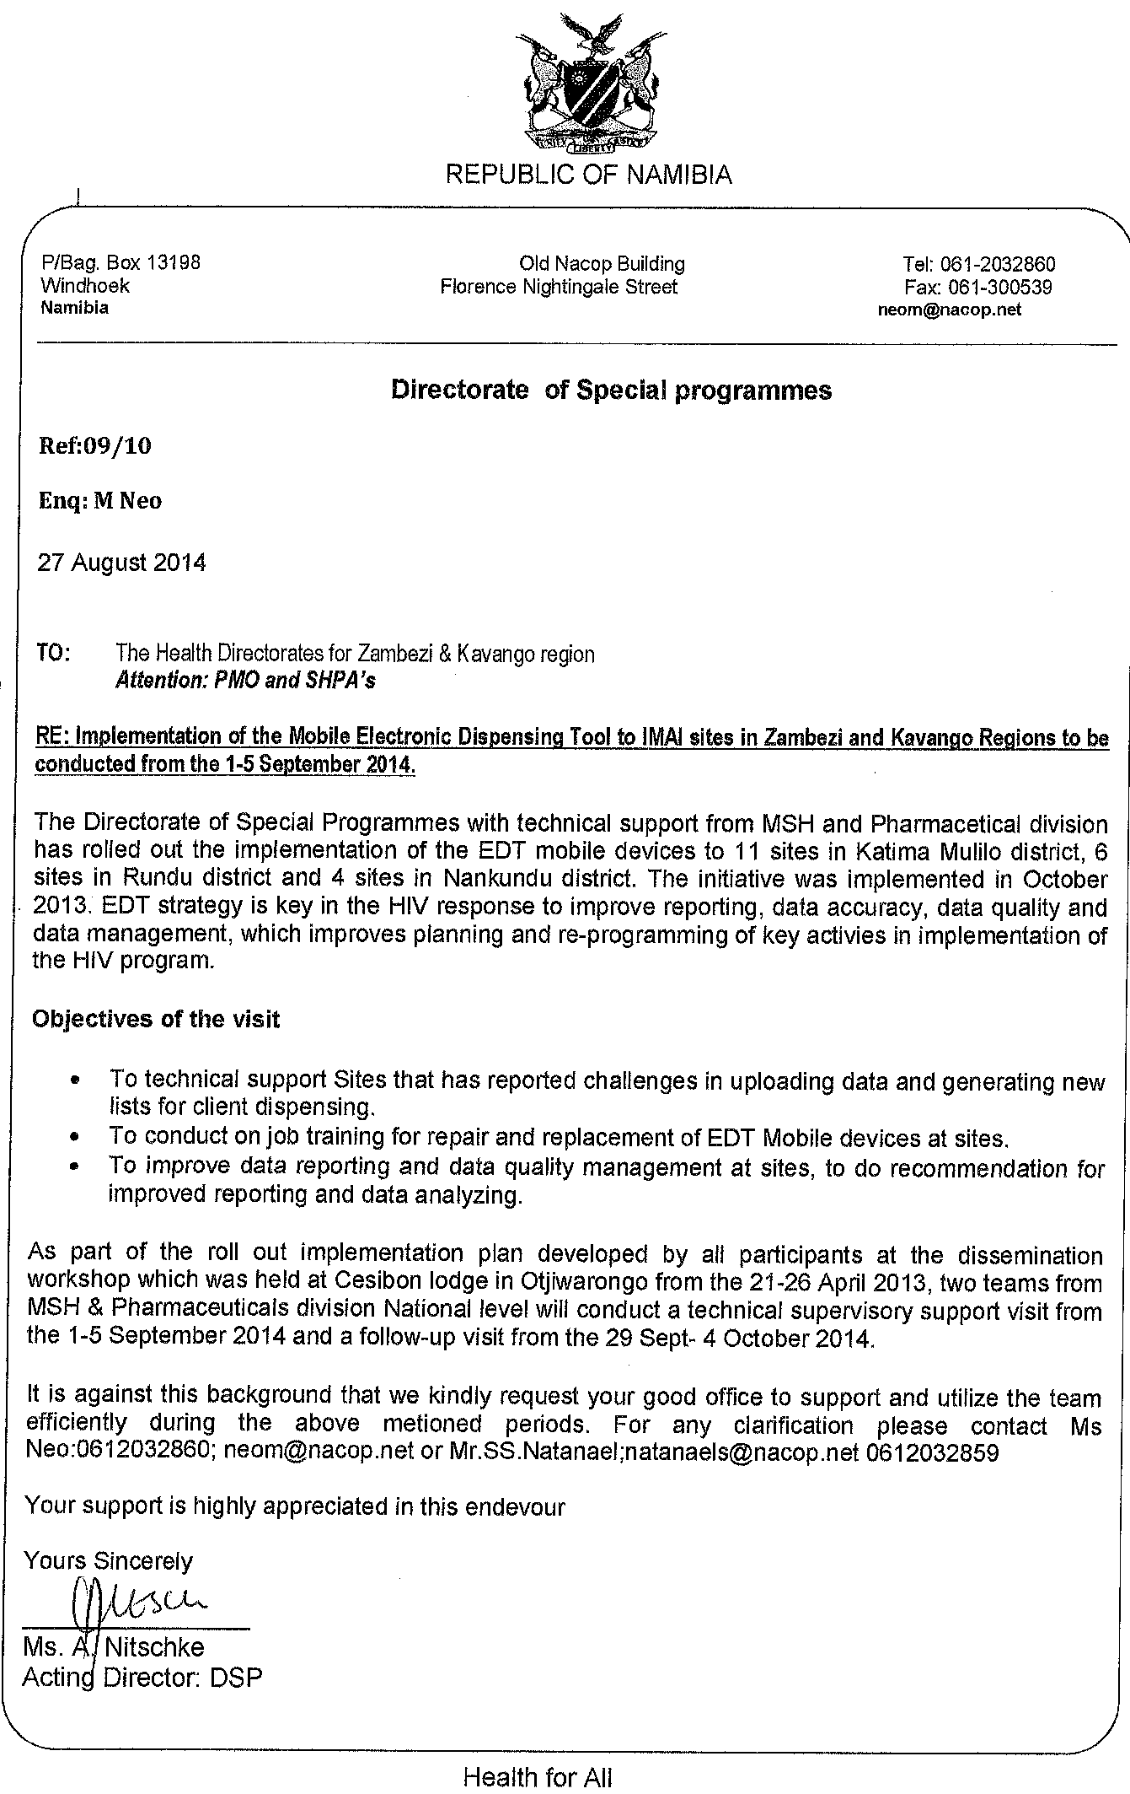

Figure 1: Letter sent to the regional managers regarding the trip

**Annex 4: Zambezi PHC facilities supported**

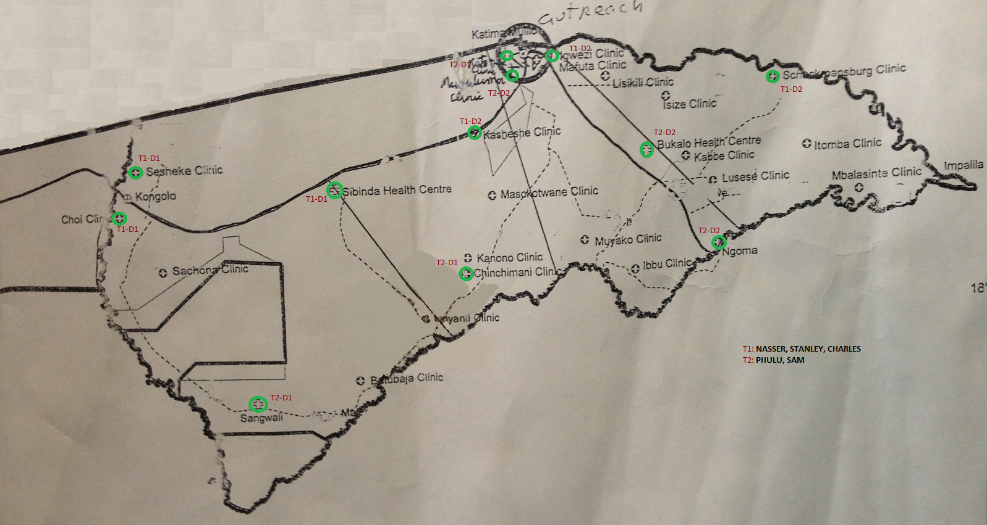

Figure 2: Primary health care facilities supported in Zambezi region (highlighted with green circles)

1. *Senior Technical Advisor, MSH/SIAPS*
2. *IT Specialist, MSH/SIAPS*